**Domain Winter Camp DAY-6**

**Name :- LAKSHAY KAMBOJ**

**Section/Group:-901-Kpit-B**

**UID :- 22BCS11185**

# Problem 1

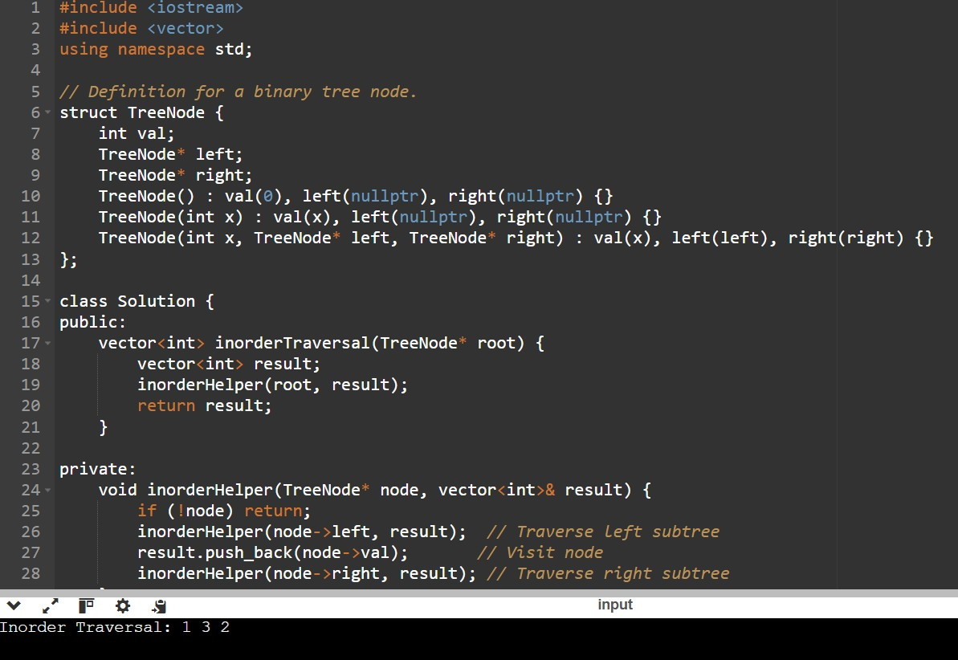

# Problem 2

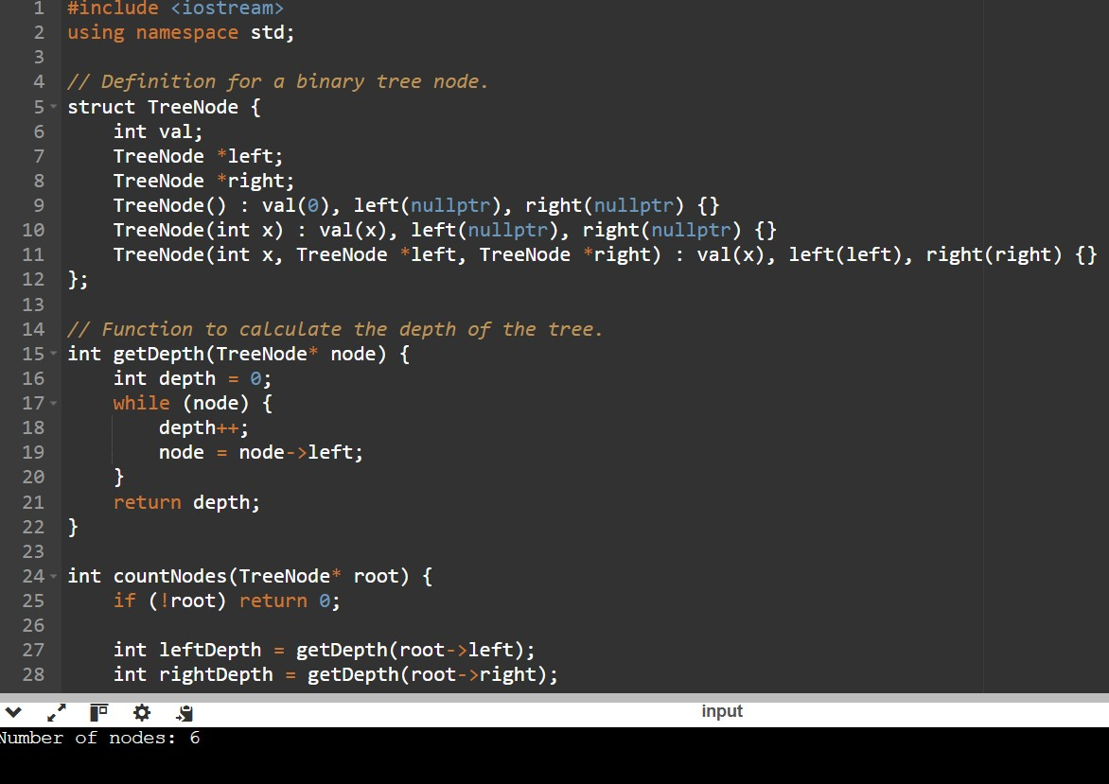

# Problem 3

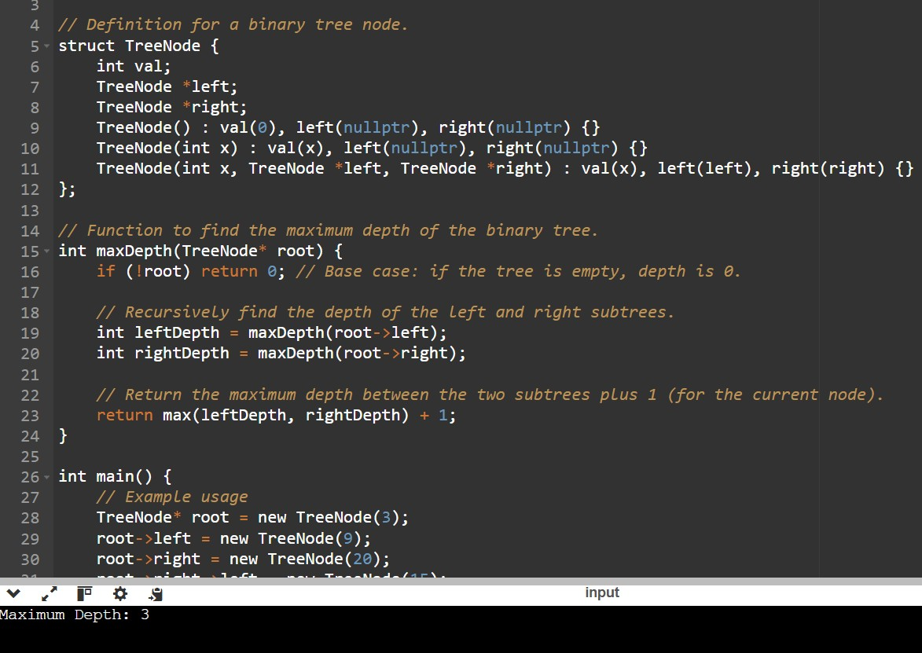

# Problem 4

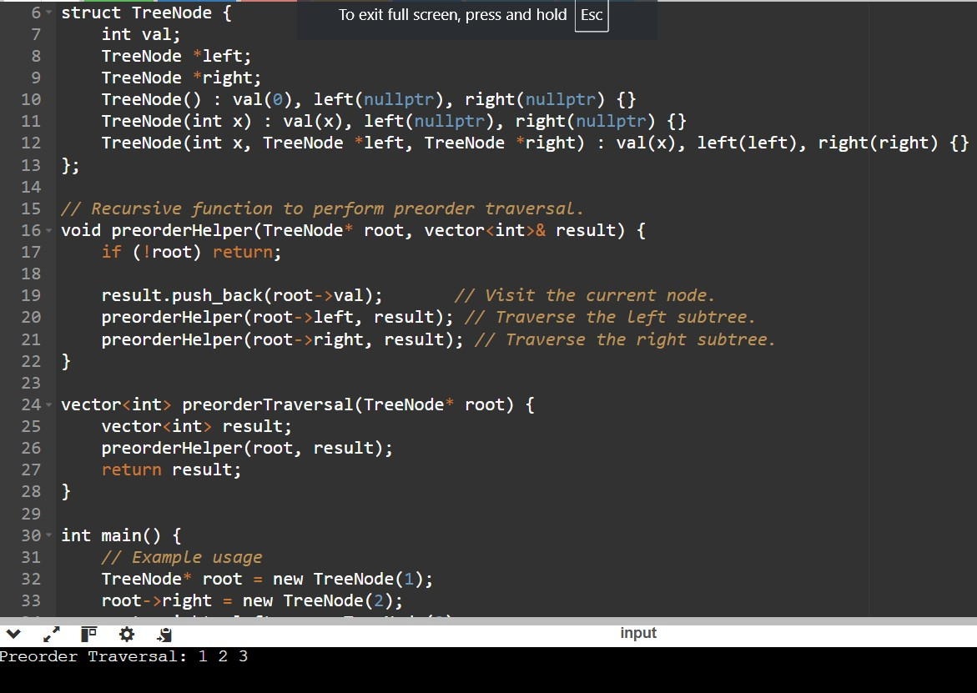

# Problem 5

